Great Lakes Athletic Trainers’ Association

55th Annual Meeting and Symposium

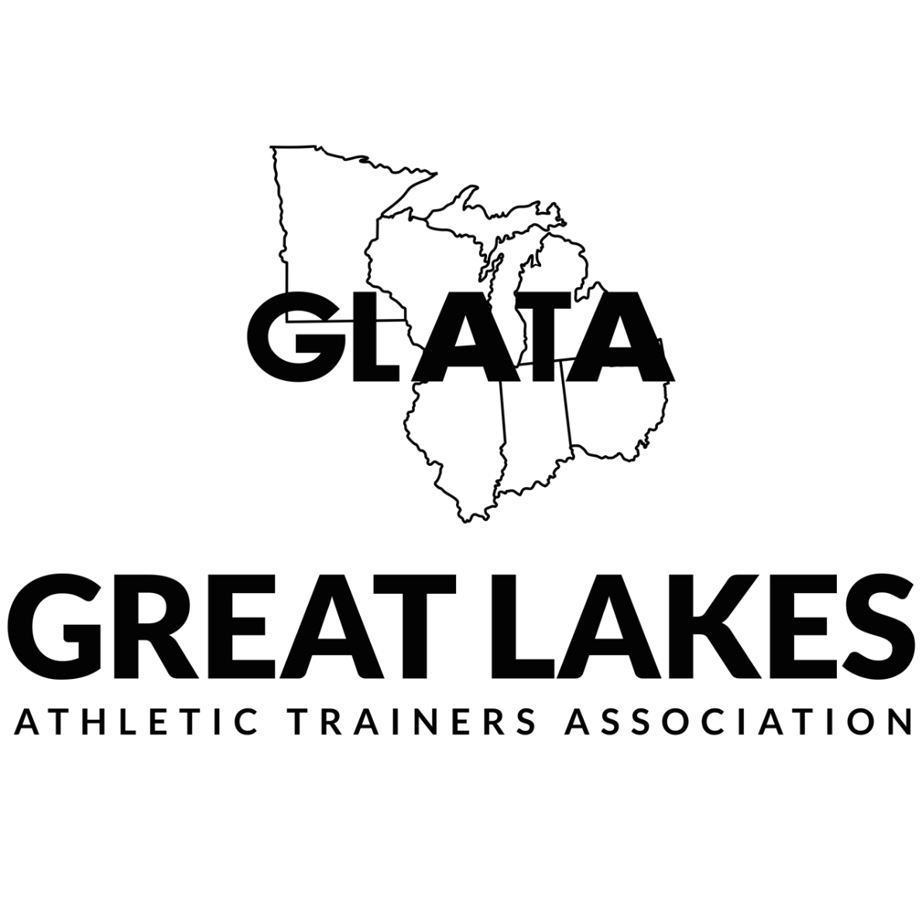
March 9th, 10th, 11th & 12th 2022

The Westin Chicago North Shore

Wheeling, IL
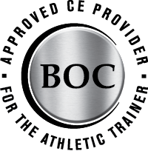
20 CEUs

“GLATA is approved by the Board of Certification, Inc.
to offer continuing education for Certified Athletic Trainers.”

*Continuing Education Units’ Statement of Credit
will be distributed within 30 days following the meeting*

Registration Hours
Ravinia Ballroom Pre-Function Area
Wed, March 9th 1:00pm – 5:00pm
Thurs, March 10th 8:00am – 3:30pm
Fri, March 11th 7:00am – 12:00pm

Exhibit Hours
Fri, March 11th 8:30am – 10:30am (Certified Only)
10:30am – 1:30pm (All Attendees)

Committee Meetings
Executive Committee
Wed, March 9th 7:30am – 6:00pm – Lake Michigan A

Committee on Practice Advancement (COPA)
Thurs, March 10th 1:00pm – 2:00pm – Botanic Garden Ballroom

Critical Incident Stress Management (CISM)
Thurs, March 10th 7:30am – 9:00am – Birch Room

Research Committee
Fri, March 11th 2:00pm – 3:00pm – Birch Room

Secondary School Athletic Trainer Committee
Thurs, March 10th 4:00pm – 5:00pm – Birch Room

Women in Leadership
Thurs, March 10th 8:30am – 9:30am – Birch Room

GLATA Conference Meeting area has FREE Wi-Fi – Network name –

No individual should be denied participation in CE programs offered by the GLATA on the basis of race, color, national origin, religion, sex, disability, military status, sexual orientation or age.

Mini Courses

Wednesday, March 9th
Mini Course Introduction to Dry Needling for Clinical Practice
3:00pm – 9:00pm Brian Hortz, PhD, ATC, SFDN, ITAT
(6 CEUs) Meg Frens, MS ATC
Lake Michigan Ballroom B
*Pre-Workshop materials will be sent on February 25th that are required to be completed prior to the workshop date.

Thursday, March 10th
Mini Course American Heart Association CPR-PR Recertification - Healthcare Provider
6:30pm – 9:30pm Matthew Marzullo, MEd, ATC
(NO CEUs) Steve Mayo, MS, ATC
Lake Michigan Ballroom
*Pre-Workshop materials will be sent on February 25th that are required to be completed prior to the workshop date.

Saturday, March 12th
Mini Course Managing the unknown, The Athletic Trainer's Role in a Mass Casualty Event
8:00am – 11:00am Darryl Conway, MA, ATC
(3 CEUs) Edward Strapp, FP-C, NRP, ATC
Birch Room

General Program

Thursday, March 10th
9:00am – 10:00am Caring for Pregnant and Postpartum Athletes
Stephanie Born
Alyssa M Matejka
Ravina Ballroom ABC

9:00am – 11:00am NATA Shared Professional Values (PV): Learning to recognize shared PV in professional practice (Learning Lab)
Kimberly Peer , Ph.D., ATC
Gretchen Schlabach
Lake Michigan Ballroom

10:00am – 11:00am Mental Health Concerns in Children and Adolescents: Screening Implementations and Impact of Injury
Julie Young, ATC, PES
Ravina Ballroom ABC

10:00am – 1:00pm GLATA Oral Free Communication Session
Free Communications provide highly structured and efficient presentations regarding the most current original research (clinical, survey, qualitative, meta-analysis/systematic reviews) and clinical case reports. Each Free Communication is 10-minutes (8-minutes presentation, 2-minutes Q&A), which concludes with clinical/practical application.
Moderators:
Botanic Ballroom

11:00am – 12:00pm Dry Needling for Pain Management: Mechanisms and Evidence
Brian Hortz, PhD, ATC, SFDN, ITAT
Ravina Ballroom ABC

11:00am – 1:00pm MARCH Trauma Assessment: An Evidence Based Approach for implementing START Triage, with the MARCH assessment (Learning Lab)
David Berry, Ph.D., MHA, ATC
Darryl Conway, MA, ATC
Edward Strapp, FP-C/TP-C, NRP, ATC
Lake Michigan Ballroom

12:00pm – 1:00pm Prescribing “Rest.” How to Optimize Recovery
Sponsored by Gatorade
TBD
Ravina Ballroom ABC

1:00pm – 5:00pm CECAT Quiz Bowl
Career Roundtable and Social Networking
Botanic Ballroom

1:00pm – 3:00pm Musculoskeletal Ultrasound: Diving Deep for Injury Assessment (Learning Lab)
Erica Miller-Spears
Lake Michigan Ballroom

1:00pm – 2:00pm Cardiovascular effect of COVID-19
Jeffrey Mjaanes
Ravinia Ballroom ABC

2:00pm – 3:00pm Implementing an EMR in Clinical Practice
Nicole DeStefano
Sarah Rowe
Ravinia Ballroom ABC

3:00pm – 5:00pm Impairment Based Rehabilitation Paradigms and the Use of Outcomes to Make Clinical Decisions (Learning Lab)
Stacey Gaven
Cameron Powden PhD, ATC
Lake Michigan Ballroom

3:00pm – 4:00pm Peer-to-Peer Support Following a Crisis: The Pandemic is a Crisis
Tanya Marquez
Ravinia Ballroom ABC

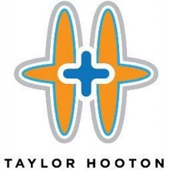
4:00pm – 5:00pm Tyler Hooton Foundation
Appearance and Performance Enhancing Substances:
The Pressure to Perform
Brian Parker
Ravinia Ballroom ABC

5:00pm – 6:30pm GLATA BUSINESS MEETING
Ravinia Ballroom ABC

7:00pm – 9:00pm Clinical Data You Can Use: Visualizing Patient Data in Microsoft Excel (Learning Lab)
David Bell PhD, ATC
Christopher Kuenze
Birch Room

Friday, March 13th
7:30am – 8:30am STATE MEETINGS
Illinois Ravinia Ballroom ABC
Indiana Lake Michigan Ballroom
Michigan Botanic Ballroom
Minnesota River Ballroom
Ohio Birch Room
Wisconsin Elm Room

8:30am – 2:00pm EXHIBIT HALL OPENS
Ravinia Ballroom DEF

8:30am – 10:30am Prehospital Assessment and Management of Chest and Abdominal Trauma: A Scientific and Practical Approach (Learning Lab)
David Berry, Ph.D., MHA, ATC
Lake Michigan Ballroom

8:30am – 9:30am TBD
Geoffrey Van Thiel
Ravina Ballroom ABC

9:30am – 11:30pm GLATA Oral Free Communication Session
Free Communications provide highly structured and efficient presentations regarding the most current original research (clinical, survey, qualitative, meta-analysis/systematic reviews) and clinical case reports. Each Free Communication is 10-minutes (8-minutes presentation, 2-minutes Q&A), which concludes with clinical/practical application.
Moderators:
Botanic Ballroom

9:30am – 10:30am Lifespan Considerations for the Patellofemoral Joint: Preventing & Managing PFP & Osteoarthritis
David Bazwtt-Jones
Grant Norte
Ravina Ballroom ABC

10:30am – 11:30pm Preparing for an MCI Event, Understanding an Athletic Trainers Roll in Triage and Scene Management
Darryl Conway, MA, ATC
Edward Strapp, FP-C/TP-C, NRP, ATC
Ravinia Ballroom ABC

11:00am – 12:00pm Maximizing Clinical Education: SP
An Athletic Training Student’s Guide to Success
Connor Burton, DAT, ATC
Elizabeth Neil, PhD, ATC
River Ballroom

11:30pm – 12:30pm Exhibit Break & Poster Session
Certified Poster Presentations
Botanic Ballroom

12:30pm – 3:30pm Leadership 4.0:
Trevor Bates, DHSc, ATC
Darryl Conway, MA, ATC
Matthew Kutz, PhD, ATC
Botanic Ballroom

12:30pm – 1:30pm Advancing Diversity, Equity, Inclusion, and Access (DEIA) Through Evidence-Based Decision Making
Jenny Toonstra PhD, ATC
Jeff Williams
Ravinia Ballroom ABC

1:30pm – 3:30pm Developing and Implementing Onboarding Best Practices (Learning Lab)
Candice Dunkin MS, ATC
Laura Harris
Botanic Ballroom

1:30pm – 2:30pm Surprising Hydrations Properties of Milk
Bob Murray, PhD, FACSM
Ravinia Ballroom ABC

2:30pm – 3:30pm COVID and the Athletic Trainer
Aaron Sage
Jason Smith
Ravinia Ballroom ABC

2:30pm – 3:30pm Pinky Newell Talk
"5 Components of Extraordinary Teams"
Lee Rubin
Ravinia Ballroom ABC

GLATA Awards Presentation
Ravina Ballroom ABC

6:00pm – 8:00pm NATAPAC Fundraiser
Ravinia Ballroom DEF

8:00pm – 11:00pm GLATA Social
Ravinia Ballroom DEF

Saturday, March 14th
8:00am – 9:00am Transforming Athletic Training into a High-Reliability Organization (HRO): Implementing “Lean” Management
David Berry, Ph.D., MHA, ATC
Lake Michigan Ballroom

9:00am – 12:00pm Safe Space Ally Training
Lorin Cartwright
Sean Rogers
Lake Michigan Ballroom
Westin Hotel Floor Plan
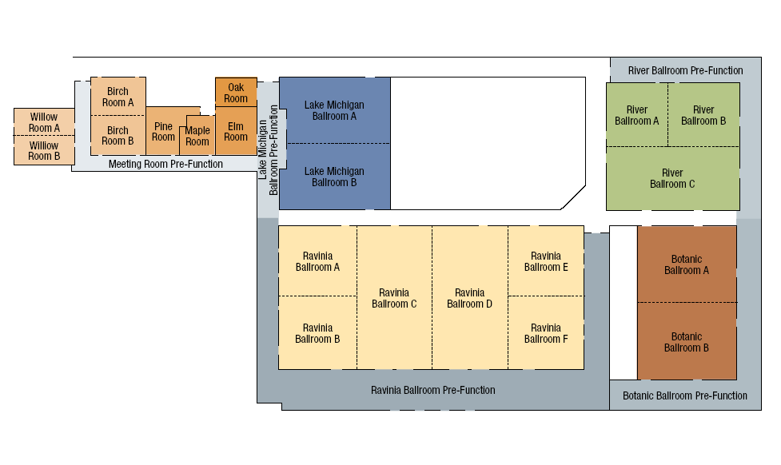
Maple
Room
Oak
Room

GLATA Future Meetings
March 8-11, 2023 - The Westin Chicago North Shore
March 13-16, 2024 - The Westin Chicago North Shore
March 12-15, 2025 - The Westin Chicago North Shore
March 11-14, 2026 - The Westin Chicago North Shore

